Resume | Bierhaalder, Lars Ingmar
 | Zaagmuldersweg 1-40  NL-9713 LA GRONINGEN  21-09-1977, Dutch, Man | info@interim-xl.com  HBO Logistics & Economics | 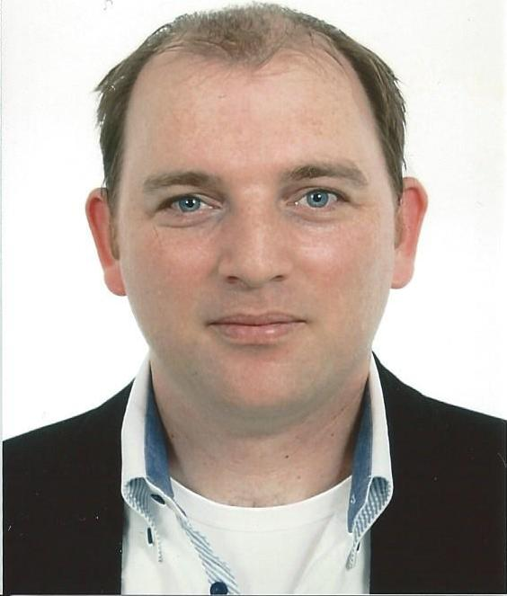

Summary | - Ten years and over of experience in logistics, supply chain and transportation.  - Self-employed since 2012  - First assignment started in 2012  - Supporting daily businesses and logistics operational processes at several companies and assigners  - Experienced in escalations processes  - Executed several process analysis for better and more optimized supply chains  - Hands-on mentality, connection between different organizational levels  - Practical features for change of logistics processes  - Multiple languages, Dutch is native but English is also fluent. German language far more than average.
Branches and countries | - Experiences in the Netherlands and Belgium  - Experiences in following industries: transportation, logistics, (chemical) production, FMCG, food & feed, automotive, Electronics, aviation, freight forwarding
Business area
- Leading and coordinating to improve logistics (administrative) processes in warehouses and production.
- Optimizing physical distribution and transportation
- Optimizing entire commodity flow
- Experience in several warehouses
ICT | - ERP Systems: SAP MM, APO, SD, Oracle and customized WMS (end-user)  - MS Office: Word, Outlook, Excel (databases, pivot tables and planning)
Implementations | - Support and advice operational departments  - Set up escalation processes upon implementation
Order Management | - Responsible for correct order management, also in cooperation with the customers  - Advise customers regarding the moment of ordering and delivery  - Receiving, processing and finalizing additional orders and rush orders  - Managing invoicing processes, including credit invoice and debit invoice
Customer Service | - Direct contact with customers who have questions regarding their orders  - Analysing and solving complaints

Experiences and projects > 3 months

11-2013  11-2014 | Dow Benelux B.V.  Terneuzen, Herbert H. Dowweg 5, 4542 NM  Producer of raw materials for several industries  Production locations Terneuzen (NL), Delfzijl (NL), Stade (D), Baltringen (D), Rheinmϋnster (D) |  | Interim Logistics Specialist  - On tactical level responsible for Epoxy Road Logistics business in Europe;  - Acting on escalations and support daily operations towards internal and/or external partners to ensure agreed deliveries with customers are being respected;  - Regular performance meetings with Logistics Service Providers and 3PL partners:  - Presenting and discussing on time performance;  - Discussing the number of complaints and type of complaints;  - Set up a plan of action to reduce the number of complaints and improving the performance.  - Set up plan of actions in cooperation with Logistics Service Providers:  - Improvements of communication due to on time loadings at loading stations and on time deliveries to customers;  - Close monitoring performance and ensure a follow-up in case performance does not improve.  - Project Inventory Reconciliation:  - Keep tracking inventory levels at outplants to pursue a 98% inventory accuracy;  - Identifying stock discrepancies and initiate a Root Cause Investigation to avoid future discrepancies.
03-2013  08-2014 | SCA Hygiene Products NV-SA  Diegem(B), Culliganlaan 1D,  1831  Sales office for retail customers in Belgium, France and Luxemburg  Production locations in Stembert(B), Hoogezand(NL), Mannheim (D) and Neuss (D) | Interim Customer Service Employee  - Supporting the Customer Service team securing the daily operational activities  - Controlling the order-to-cash process  - Daily inventory monitoring up to 5 days before delivery date  - Implementation of the Backorder Processing: Improving service level by interactive insight of the stock levels
01-2012  12-2012 | SCA Hygiene Products B.V.  Zeist (NL), Arnhemse Bovenweg 120, 3078 AH  Sales office for retail customers in the Netherlands  Production locations in Stembert (B), Hoogezand (NL), Mannheim (D), Neuss (D)  Warehouse location in Wijchen (NL) | Interim Logistics Service Employee  - Assignment for 10 months, supporting the Customer Service team  - Controlling the order-to-cash process  - Internal and external communication with all involved parties  - Set up planning towards customer’s promotional activities and processing in SAP  - Project Interactive Backorder Processing: set up an interactive way of controlling the inventory management, 5 days before delivery  - Project Free of Charge: set up a new format of Free of Charge requests from internal customers  - Project promotional analysis: developing analysis forecast versus orders for one customer
04-2011  10-2011 | FrieslandCampina DOMO  Beilen(NL)  De Perk 30, 9411 PZ  Ingredients and Nutritions  Production locations in Marum (NL), Workum (NL), Gerkesklooster (NL), Dronrijp (NL)  Warehouse locations in Bedum(NL), Veendam (NL) and Borculo (NL) | Order Fulfillment Officer  - Sales support offspecs products for order entry (also in SAP)  - Mapping and optimizing inventory management regarding to offspecs products  - Set up production plans for infant food ingredients towards internal and external clients  - Control and coordination with internal and external customers for reconciliations  - Set up document flow with DHL and documented in SOPs  - Intensive communication with DHL
07-2009  04-2010 | Expeditors B.V.  Schiphol  Ganderweg 1, 1118 LH  Freight Forwarding, import, export, warehousing, 3PL, 4PL | Distribution Agent  - Order processing for a dedicated customer (import and export) including documentation, also airfreight in a 4PL participation  - Daily physical and systematical inventory control between warehouse systems  - Planning and forecasting per month and year quarter  - Improvement of communication, both internally and externally  - Analytics and forecasts according to KPIs
11-2007  04-2009 | UTi Nederland B.V.  Schiphol (NL)  Carpronilaan 12, 1118 ZN  Freight Forwarding, import, export, warehousing, 3PL, 4PL |  | Logistics Administrator  - Planning and organizing deliveries, including airfreight  - Participation in a 4PL and optimizing the supply chain, including planning  - Set up KPIs for customers  - Set up communication matrix for customers and suppliers  - Formatting and updating work instructions

08-2004  08-2007 | Menzies Aviation  Schiphol (NL)  Anchoragelaan 50, 1118 LE  Independent handler for passenger flights and freight cargo | Warehouse Medewerker Menzies World Cargo  - Instructing (new) colleagues and coordinate upon incoming materials  - Acceptance of import and export materials  - Build up and breakdown ULD’s  - Transport ULD’s to Apron and gates
Projects < 3 months
- Order Processing Officer at KonicaMinolta supporting the OPC team upon daily businesses

