Fleet management
Take advantage of technical knowledge, an extensive dealer network and by cheaper equipment from now on. You can already start saving money in 2016 at the cost of your fleet without hiring yourself a specialist.

Please call for an informal chat or a quick scan of your current situation.
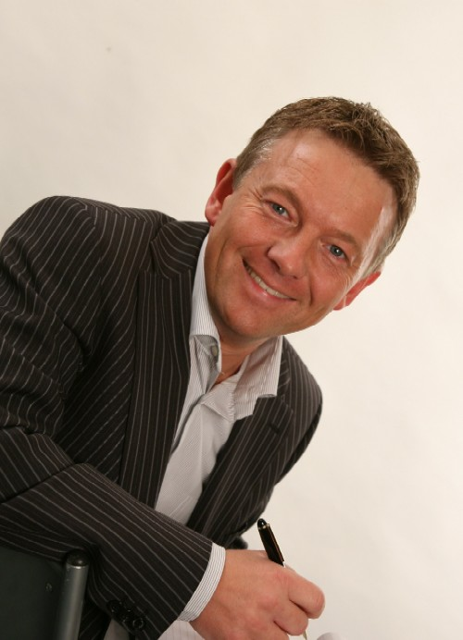 | - Optimal deployment of equipment  - Quick Scan and benchmark current situation  - Minimization of Total Cost of Ownership  - Early maintenance prevents problems later  - Consultancy in type and brand vehicles  - Purchase new equipment and support delivery  - Sales and or trade-in of old equipment  - Large network operators for 2nd hand Europe  - Dealer of Bedrijfswagenland.nl  - Technical knowledge and 20 years of experience  - Contacts with all dealers in Europe  - Manage Leases  - MOT, tires, rental  - Fluent English / German / Dutch | 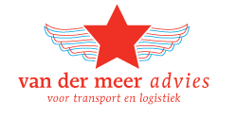
 |  | Adres  Telefoon  Bank  Kvk | De Line 16  8411TV JUBBEGA  +31 6 46 84 23 31  NL21 RABO 0144 2965 86  011.177.76
References | - Van der Meer advice is responsible for the fleet of the laundry cleaning company de Blinde (8 vehicles), Rentex Floron (18 vehicles), van der Meer paving (2 units) and US Bilang (30 units).  - In the past I have experienced similar at Van der Vlist, Van der Werff Logistics, Oenema Transport, Gutmann heavy transport.
Customers  and experience | 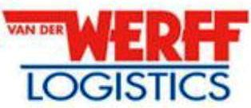  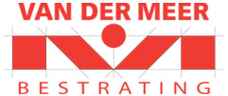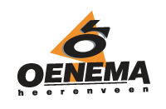
Trade  partners |   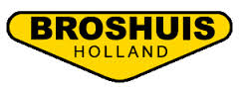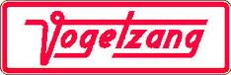      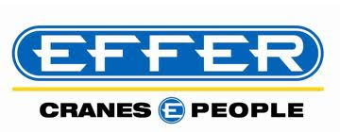  

Curriculum Vitae
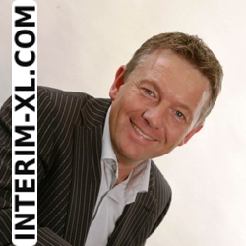

Name: Ing. Bouwe van der Meer
Graduate Logistics Manager (FH)

a De Line 16, 8411 TV Jubbega, NL
m +31 6 46 84 23 31
e info@interim-xl.com
w www.interim-xl.com
b 09-06-1970, 45 Years old

Resume in headlines

- Raised in a family business, a transport company and trade in garden articles
- First restructuring project at the age of 23 (sold transport department with 7 trucks)
- 15 interim projects finished since 2006, first project at the age of 36
- Specialized in negotiation techniques, both procurement and sales
- 30 years’ work experience trade, procurement, production, supply chain, transportation and logistics
- Strong background in IT, sales, procurement, distribution, manufacturing, buying and management
- Multilingual (NL, DE, UK) and employable worldwide

Outstanding projects and experiences

- Losses in freight and forwarding companies converted into profit
- Organizing workshops “turnaround marketing, how to escape the big squeeze”
- International business development projects and cold acquisition
- Strong negotiating technics and decisive in strategic sourcing / purchasing
- Restructuring of business processes, acquisition and financing of foreign companies
- IT systems such as Oracle, QAD, MFG-PRO, and Microsoft Dynamics implemented
- Optimization of total cost of ownership fleet management
- Optimization supply chains, warehousing, pick / pack, inbound and outbound procedures
- 10 X own MS ACCESS Tool developed, expert on SQL (massive data processing)

Buying experience

- European and worldwide transport (road, rail, river and sea, multimodal)
- Storage at third parties, warehouse equipment and forklifts
- Vehicle fleets (trucks, wheel loaders and cars), fuel and spare parts
- Raw materials for the concrete industry (sand, cement, additives)
- Advertising, DTP, photography, printing, brochures and digital media (internet)
- Computers (PCs, servers, board computers) and software (ERP, TMS)
- Office supplies, temporary workers, rent offices and premises

Branch and Countries

- Experience in industries: wind energy, transportation, logistics, healthcare, manufacturing, concrete products, building, laundry, merchandising, FMCG, food, automotive and electronics
- Experience in countries: UK, USA, Sweden, Germany, Poland, Switzerland, Austria, Belgium and France

Personal strengths

- Self-starter, honest and loyal, warm personality
- Can get along with both managers, owner / Stockholder and workers
- Very creative in finding solutions to “impossible” problems
- Innovative thinking and action, enthusiasm and perseverance
- Strong persuasion and excellent communication skills
- Proven references in managing complex projects
- Successful negotiations on the international level

Interim mandates and projects > 3 Months

Consultant Procurement and Logistics (80%) | 05/2015 – 12/2015
Enercon Gmbh, DE-Bremen, Wind turbines Producer, 4,6 billion. EUR, 20.000 FTE
- Supporting and advising department Logistics and Purchasing Transport and Cranes (cat spend 500 Mio)
- Supervise procurement projects and negotiating with vendors for projects in Europe
- Develop logistic calculations models for each country in Europe for Transport (Heavy) and Cranes (600 Tons)

Consultant Procurement and Logistics (20%) | 07/2014- 09/2014
Gräper Gmbh, DE-Ahlhorn, Concrete Transformation Houses producer, 100 Mio. EUR, 700 FTE
- Supporting and advising department Logistics and Purchasing
- Supervise procurement projects and negotiating with vendors
- Tender Transport and Cranes Europe (3 Mio)

Interim Category Lead Buyer (100%) | 12/2014 - 05/2015
Avebe Potato Starch, NL, 1300 FTE, 650 Mio. EUR
- Restructuring of procurement and organization of transport and warehousing worldwide (spend 70 Mio):
  - 2M tons Potatoes to factories, 600K tons of potato starch in bulk, big bags and pallets moved by road transport and maritime containers worldwide
  - Storage of packed goods (120.000 m2), bulk with external parties and external silo parks (200K ton)
- Issue Tenders and contract negotiating:
  - Transport and loading of containers to Rotterdam (saving €100K)
  - Internal transport of potato starch through bulk trailers (saving €400K)
  - Sea transport of maritime containers by shipping companies
  - Potato transportation from the field to the factory (saving €200K)
  - Road Transport Europe, 6.000 FTL loads (saving €500K)
- 5 new carriers selected and implemented for transport packages of 10M €
- Legal problems with suppliers solved using lawyers and attorneys
- Development and implementation of new purchasing strategy and multi-year procurement plan
- Further development of international intermodal freight volumes from road to rail / barge (saving €600K)
- Examined contracts of 20 vendors and decreased liability and risks
- Advised senior management in logistics / transportation on liability and litigation
- Implemented new negotiating techniques in renewing contracts with vendors.

Interim Manager Sales and Logistics | 02/2014 - 07/2014
Studio 100 Media, DE-München, Media Producer, 1000 FTE, 170 Mio. EUR
- Short term replacement of 2 Key staff members, Head of Merchandising and Supply Chain Manager
- Planning, buying and replenishment of 500 articles in China and Europe
- Liaise with headquarters Schelle Belgium demand, prices and European needs
- Negotiating and buying displays from cardboard factories
- Daily management and training employees department sales and logistics
- Optimize customer contracts, Supply Chain and SLA of with logistics service providers
- Research and development of new logistics model Europe (from 4 warehouses by 2)
- Optimization of Microsoft Dynamics AX (ERP) and creation of new reports (Crystal Reports)
- Write and ISO procedures for all processes in German language

Interim Logistics Manager / Interim Buyer | 09/2013 - 12/2014
Laundry service de Blinde, NL-Heerenveen, Healthcare, 200 FTE, 15 Mio. EUR
- Restructuring fleet management (technical and financial)
- Optimization of the material flow of clean and dirty bed sheets linen, textiles and clothing from the laundry to the hotel chains (300.000 kg pro week)
- Buying and selling trucks, fleet analysis, insurance and contacts with Department of Motor Vehicles
- Supplier management and auditing, maintenance and repair of vehicles
- Interim category buyer for Fuel (800K€), Trucks and parts (4M€) and Personal (400K€)
- Tenders, RFQ prepared and completed for road transport, labour and maintenance
- Release invoices through Purchase to pay, manage exceptions (2x bankruptcy’s suppliers)

Interim Business Development Manager |  | 05/2013 - 10/2013
Gutmann Heavy Logistics AG, CH-Zug, Heavy Transport Logistics, 100 FTE, 35 Mio. EUR
- Acquisition project cargo in Europe through cold calling, internet, emails, newsletters and presentations
- Branches: wind energy, power plant construction, steel mills, oil and gas and top 100 companies germany
- Design new website, brochures, newsletters and marketing strategy
- Buying and organization transport, cranes, special equipment for projects in Europe
- New offers to prospects: 2,5M€ with 250K€ turnover
- Attended trade fair Transport & Logistics Munich and Break Bulk in Antwerp
Interim logistics Manager / Buyer Logistics | 09/2013 - 02/2014
Rentex Floron BV, NL-Bolsward, Healthcare, 350 FTE, 33 Mio. EUR
- Improved efficiency planning trucks and creating 500K savings euro annually
- Decreased number of trucks from 34 to 24, sold old leftover trucks through internet auction
- Optimization of the material flow of clean and dirty bed sheets linen, textiles and clothing from the laundry to hospitals, nursing home, disabled (400.000 kg pro week)
- Interim Buyer for IT Systems, Fuel (1M€), Trucks (5M€) and Personal (400K€)
- Tenders, RFQ prepared and completed for road transport, labour and maintenance

Manager new business | 9/2010 – 2/2013
Holtrop van der Vlist BV, Heavy Transport and Machinery, 100 FTE, 18 Mio. EUR
- 120 new customers earthmoving industry, heavy equipment and 2 M € new revenue per year
- Define sales strategy and implement into sales plan, making prices and working on tenders (CAT)
- Management of 1000 Prospects (cold calling, newsletters, visiting) and 600 customers
- Responsible for accounts receivable management and contact person for major accounts and IT
- Hiring and purchasing contractors for special projects, road transport and sea freight
- Managed outbound automotive projects, export equipment through sea transport
- Development of own CRM Database and introduced GPS System TraSec
- Attended trade fair Transport & Logistics Munich and Break Bulk in Antwerp

Interim Commercial Director | 4/2007 - 9/2010
Oenema Transport, Taxi / ambulance, Transport and Logistics, healthcare, 200 FTE, 20 Mio. EUR
- Responsible for the staff, Transport Department 70 drivers and 5 office workers
- Restructuring transportation department, € 600 K annually loss converted
- Purchase / Buying of capital equipment such as trucks, forklift, fuel and temporary workers
- Negotiate tariffs with charters and other transport companies
- Set up new departments:
  - Automotive inbound logistics (10 trucks for Scania Zwolle)
  - Food and conditioned transport for Albert Heijn (12 trucks)
  - Furniture transport from Germany to Holland (3 trucks)
- 50 new clients and 2M € new turnover
- Selling department ambulance healthcare (5 M €) to Kijlstra Personenvervoer
- Preparation acquisition company through 2 sons and training in France
- 4 European tenders passenger transport disabled people to hospitals (€ 4M)
- Conducting litigation and contact person for banks, taxes, customers and suppliers
- Warehouse activities development (5,000 pallets) and cross docking for new clients

Interim Buyer and Logistics | 02/2008 - 05/2008
MBI Concrete Products, NL-Kampen, Concrete Production, 200 FTE, 35 Mio. EUR
- Optimizing flows of goods, storage of raw materials and finished goods
- Optimizing production Kampen NL (200.000 ton) and Veghel NL (300.000 ton)
- Tender and RFQ written for Outbound Transport finished goods and negotiate contracts
Interim Transport Manager | 01/2007 - 06/2007
Holcim Concrete Products, NL-Rotterdam, Concrete Production, 200 FTE, 30 Mio. EUR
- Planning, preparation and organization of transportation of building materials (Daily 80 trucks)
- Contact person for drivers, customers, freight forwarders and production staff
- Tender (RFQ) written for outbound transport finished goods and negotiate contracts

Interim Director | 07/2006 - 01/2007
Concrete Production Kijlstra, NL-Veendam, Concrete Production, 35 FTE, 20 Mio. EUR
- Heading team of 35 FTE, production, buying, sales, marketing and administration
- Buying all equipment like forklift trucks, wheel loaders, raw materials like sand cement and minerals
- Master production planning in SAP R3 and liaise plans with headquarters
- Solved production problems (interruptions) and prepared expansion of production to 200% in 2007
- Determine new marketing strategy (dealers and end customers) and define selling prices
- Turnaround marketing: create new product range called "Colors of the Earth"
- Managed 2 sales managers and took care of the biggest customers myself

Managing Director | 2/2001 -8/2006
Van der Werff Logistics BV, Transport and Logistics, 100 FTE, 12 Mio. EUR
- Responsible for the staff, Transport Department 75 drivers and 10 office workers
- Close and reorganize office Harderwijk (€ 3M and 25 trucks)
- Purchase / Buying of capital equipment such as trucks, forklift, fuel and temporary workers
- Acquisition and integration Hamstra Transport (30 trucks)
- Defined and implemented new tariff system for charters (based on miles)
- Growth of 3M € to 10M € in 5 years and 35 to 80 trucks in 5 years
- Development of warehouse operations, organize and build warehouse (10,000 tons)
- Tenders in transportation (€ 4M) and conducting litigation
- Contact person for banks, taxes, customers and suppliers
- Purchase and implementation TMS Plan and Go! (125K€) and Transics Boardcomputers (200K€)

Supply Chain Manager | 1/1996 – 1/2001
Xerox Distribution Europe BV, Electronic, 200 FTE, 200 Mio. EUR
- Demand Planning, Purchasing 3,000 articles in Mfg/Pro and Oracle, 20 M € value
- Organising inbound container shipments from USA, China, Korea to Europe
- Organising outbound worldwide shipments, pallets, parcels, and full trucks and air cargo
- Purchasing cardboard parts in the UK (€ 1M) and organize transport UK>NL
- Management internal logistics: storage and release of salesorders
- Planning production department of configuring printers to salesorders (also managing BOM’s)
- Responsible for shipments to customers in Europe, damages and organizing quarterly endings
- Organized the complete removal DC from Heerenveen to Venray (6.000 pallets)
- Transfer of inventories (€ 100M) and integrating all IT systems
- Implementation of QAD MFG / PRO and Oracle in Heerenveen and Venray (superuser level)

Interim mandates and projects < 3 Months

Interim Manager | 08/2014 - 09/2014
Inter-East Cargo BV, BU-Sofia, Transport, 15 FTE, 6 Mio. EUR
- Negotiated and sold GmbH including 12 Lease trucks and Bulgarian drivers to Schavemaker Beverwijk
- Defined and prepared all the financial contracts between buyer, lease company and seller

Consultant Business Development | 10/2014- 10/2014
Rail and Road Logistics, DE-Berlin, Heavy Project Cargo, 20 FTE, 13 Mio. EUR
- Organising 2 day Workshop „Turnaround Marketing, Social Media, Internet and Acquisition“

Consultant Business Development | 02/2013 - 02/2013
Max Wild, DE-Berkheim, Transport and Logistics, 450 FTE, 100 Mio. EUR
- Organising 2 day Workshop „Acquisition BAUMA Trade Fair München“ Heavy Equipment
- Consulting acquisition prospects Heavy Transport and project cargo

Consultant Business Development | 06/2005 - 07/2005
Buiter Beton, NL-Zwolle, Concrete Production, 28 FTE, 22 Mio. EUR
- Workshop „Internet und E-commerce“. Design and structure new Website

