Transport Consultancy – Interim-XL
Consulting for  transport and supply chain | 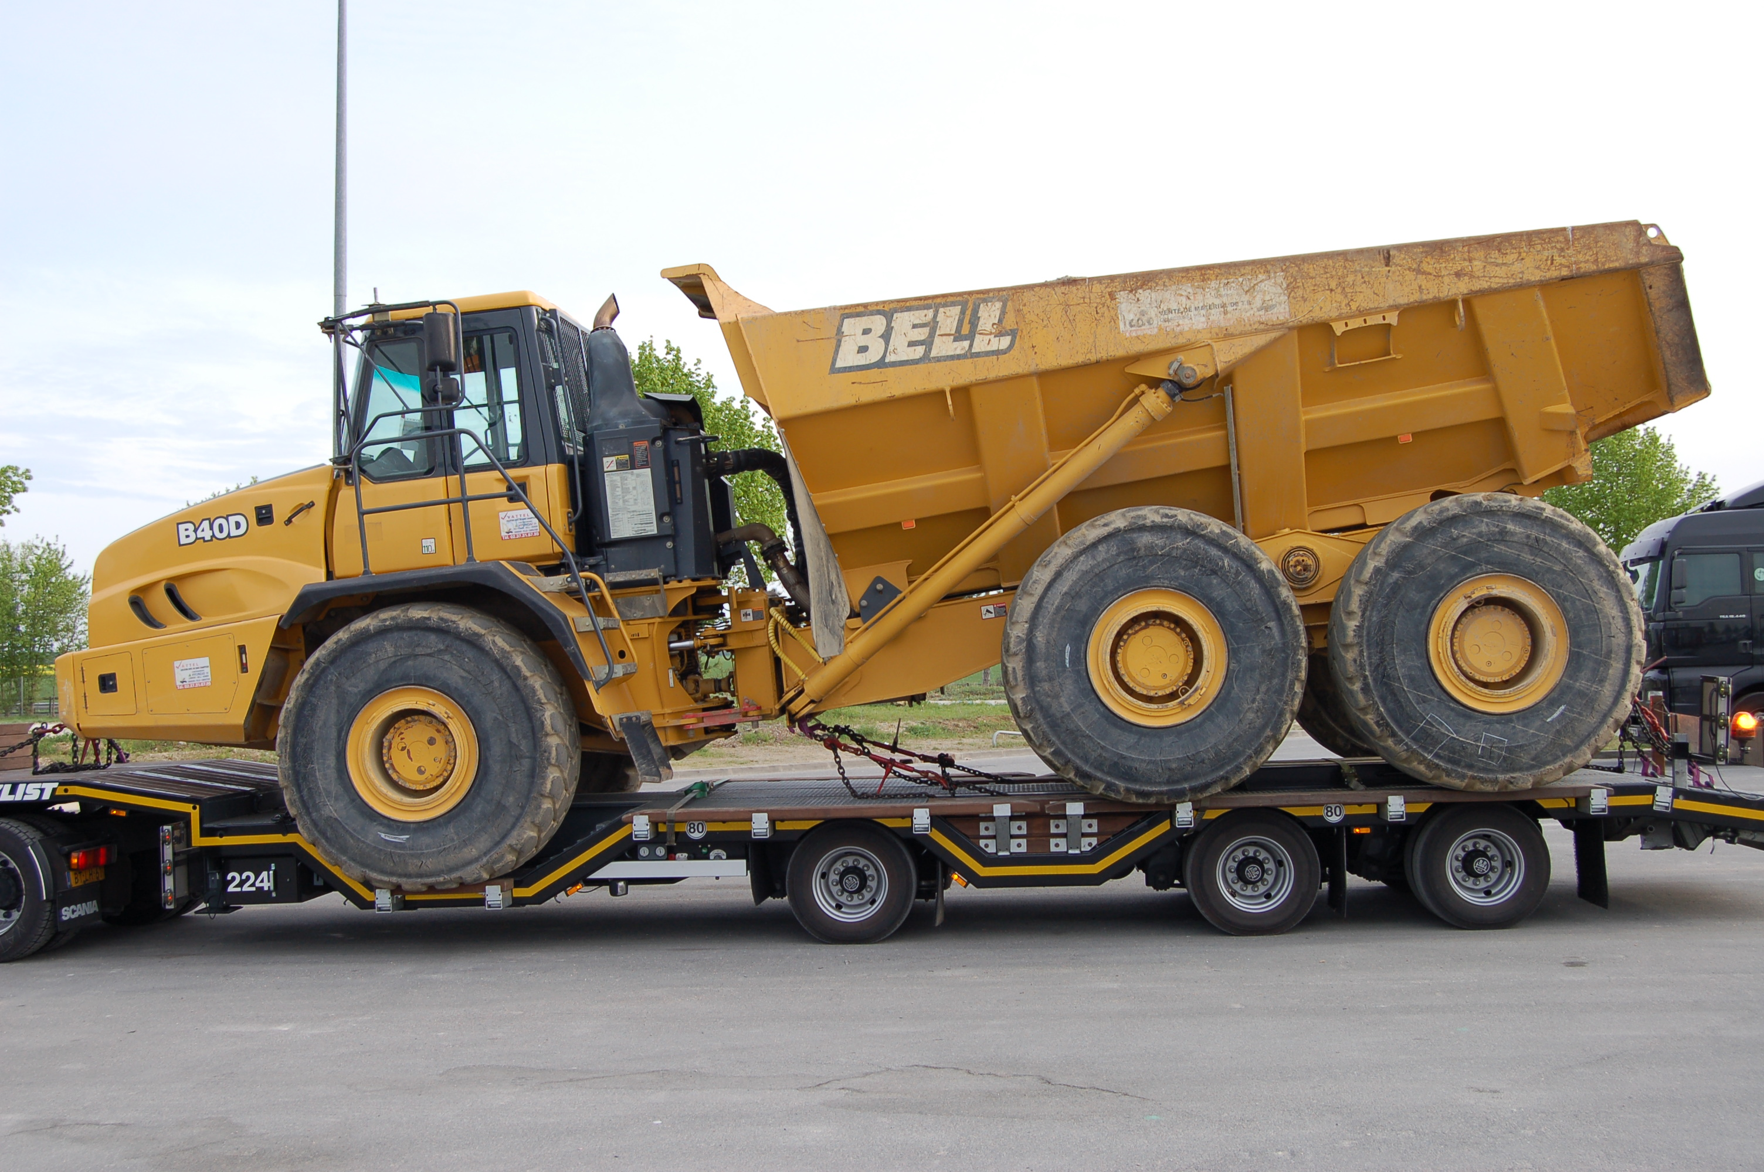 | 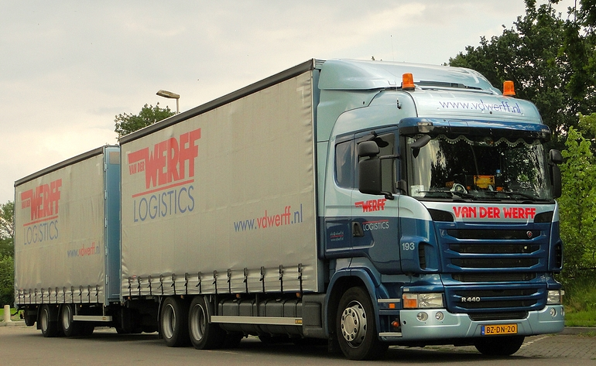 |  |  | 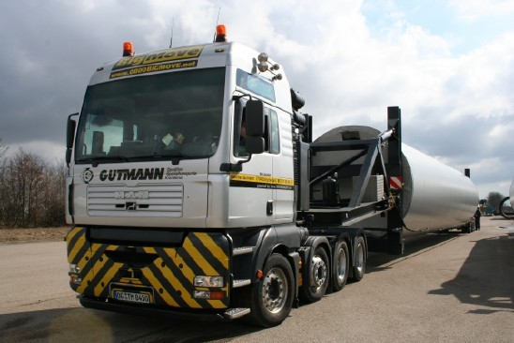
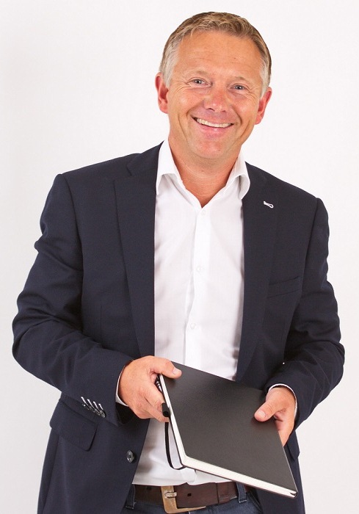 | Consultancy Service  Support customers in procurement and management of logistics services  Analysis and evaluation of transport rates and supply chain effects  Developing strategies for global freight procurement and fleet management  Optimization of logistics costs and logistics processes  Commercial and technical training and coaching staff for all forms of transport  Design of tendering and contracting of logistics services  Growing experience and responsibility in ongoing projects  Sophisticated calculation models for heavy transport, project cargo and large cranes  Own developed tender documents, ITT, RFI and RFQ  My Profile  Strong analytical and conceptual skills  Knowledge of all European and Worldwide transport rates and forwarding companies  Large experience with multimillion and worldwide transport tenders  Strategic thinking combined with process and market and commercial understanding  Sound knowledge of MS Office, SAP, MS Dynamics, Access, MS SQL Server  Fluent in English, German and Dutch  My Experience  25 years’ experience in 10 industries and in 10 countries  Active as interim manager since 2006, completed 20 projects  Executed Interim or consultancy projects with category spends from 2 million to 500 million euro  Branches  Heavy transport, wind energy, machinery, steel, molding members, agriculture, grain, furniture,  bulk, construction materials, laundry healthcare, manufacturing, textile, merchandising,  FMCG, food and refrigerated transport, automotive and electronics  Countries  UK, USA, Canada, Brazil, Africa, Sweden, Germany, Poland, Switzerland, Austria, Belgium and  France  Modalities  Land transport, inland waterway, air, train, bulk transport, deepsea, shortsea
 | Top References  Royal Haskoning  Gräper-Gruppe  Enercon Gmbh  AVEBE Potato strach  Studio 100 Media  Rentex Floron Textil  Gutmann Heavy Logistics  Van der Vlist Logistics  Oenema Transport  Xerox Color printers  Van der Werff Logistics |  | Africa, Ethiopia  DE-Ahlhorn  DE-Bremen  NL-Groningen  DE- München  NL-Amsterdam  CH-Zug  NL-Rotterdam  NL-Leeuwarden  NL-Heerenveen  NL-Heerenveen | Develop and procurement of mining transport  Concrete transport of transformer stations  Heavy transport and supply chain  Transport and potato starch  Transport and storage of media  Cargo & storage textile  Worldwide project cargo  European machinery transport  Transportation of food  Worldwide transport of electronics  European transport of building materials
Improve your freight  rates and conditions?  Please send your  Request by e-mail to  info@interim-xl.com | Interim XL - Bouwe van der Meer - De Line 16 Jubbega - 8411 TV Jubbega  +31 6 46 84 23 31 - www.interim-xl.com - info@interim-xl.com
Curriculum Vitae
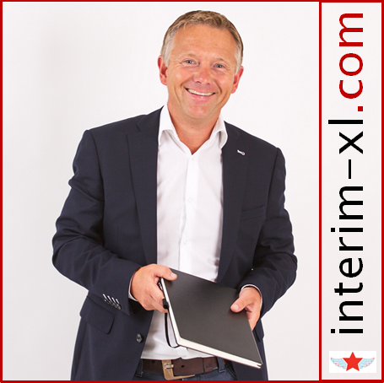

Ing. Bouwe van der Meer
Graduate Logistics Manager (FH)

Consultant and interim manager
Transport and logistics

a De Line 16, 8411 TV Jubbega, NL
m +31 6 46 84 23 31
e info@interim-xl.com
w www.interim-xl.com
b 09-06-1970, 45 Years old

Resume in headlines

- First restructuring project at the age of 23 (sold transport department)
- 19 interim projects finished since 2006, first one at the age of 36
- Specialist solving international complex transport and supply chain problems
- 20 years’ experience in negotiation transport and logistics, both procurement and sales
- 30 years’ work experience trade, procurement, production, supply chain, transportation and logistics
- Strong background in IT, sales, procurement, distribution, manufacturing, buying and management
- Multilingual (NL, DE, UK) and deployable worldwide

Outstanding projects and experiences

- Restructuring procurement of transport and logistics with category spends up to € 500 Mio
- Issuing and writing high level and complex worldwide transport tenders
- Losses in freight and forwarding companies converted into profit
- Strong negotiating technics and decisive in strategic purchasing
- Optimization supply chains, warehousing, pick / pack, inbound and outbound procedures
- Implemented IT systems such as Oracle, QAD, MFG-PRO, and Microsoft Dynamics
- 10 X own MS ACCESS Tool developed, expert with SQL (massive data processing)

Buying experience

- European and worldwide transport projects (project cargo, break bulk, road, rail, river and sea, multimodal)
- Storage third parties, warehouse equipment, port handling and forklifts
- Vehicle fleets (trucks, wheel loaders and cars), fuel and spare parts
- Raw materials for the concrete industry (sand, cement, additives)
- Advertising, DTP, photography, printing, brochures and digital media (internet)
- Computers (PCs, servers, board computers) and software (ERP, TMS)

Branch and Countries

- Experience in industries: mining (Africa), wind energy onshore (Europe and Canada), shipping and port handling (break bulk, RORO and project cargo), healthcare, manufacturing, concrete products (stones and tower sections), building & construction, laundry, merchandising, FMCG, food, automotive and electronics
- Experience in countries: UK, USA, Canada, Brazil, Africa, Sweden, Germany, Poland, Switzerland, Austria, Belgium and France

Personal strengths

- Self-starter, honest and loyal, warm personality
- Can get along with both managers, owner / Stockholder and workers
- Very creative in finding solutions to “impossible” problems
- Innovative thinking and action, enthusiasm and perseverance
- Strong persuasion and excellent communication skills
- Proven references in managing complex projects
- Successful negotiations on the international level
Interim mandates and projects > 3 Months

Transport and contracts expert | 09/2015 -12/2015
Royal Haskoning, NL-Nijmegen, Consultancy and Engineering, 7000 FTE, 400 Mio. EUR
- Mapping and defining supply chain large and complicated mining project in Africa (high risk country)
- Develop tender strategy and sourcing documents for transport, and handling 1.000.000 tons annually
- Investigation and defining truck types (220 vehicles), route and tracks (600 km desert track) in Africa

Consultant Procurement and Logistics |  | 05/2015 – 12/2015
Enercon Gmbh, DE-Bremen/Aurich, Wind turbines Producer, 4,6 billion. EUR, 20.000 FTE
- Report to senior management and board of directors
- Full analyse of all European Heavy Transport on carriers, vehicle types and rates (60.000 transports, 500 Mio)
- Benchmark of all transport rates and forwarders in European countries
- Developed price calculation tools for heavy transport and large cranes
- Supervise and on the job training of buyers on negotiating with carriers
- Prepare and negotiate high risks contracts (> € 30 Mio) with management
- Defining, executing and negotiating 4 large European Transport Tenders
- Worked on several other projects: Wind park Niagara Falls Canada, shipping deep sea and port handling procedures and rates, finding and hiring cranes in France, UK and Ireland for tower erection.

Consultant Procurement and Logistics | 07/2015- 12/2015
Gräper Gmbh, DE-Ahlhorn, Concrete Transformation Houses producer, 100 Mio. EUR, 700 FTE
- Restructuring procurement of logistics and deployment of cranes Europe
- Defining new standard transport contract and SLA
- Prepare and negotiate bigger projects and contracts with carriers
- Organizing tender heavy transport and deployment cranes Europe

Interim Category Lead Buyer (100%) |  | 12/2014 - 05/2015
Avebe Potato Starch, NL, 1300 FTE, 650 Mio. EUR
- Restructuring of procurement and organization of transport and warehousing worldwide (category spend € 70 Mio)
  - 2.000.000 ton Potatoes to factories
  - 600.000 ton transport and storage of potato starch in bulk, big bags and pallets
  - Procurement of external warehouses of 120.000 m and 200.000 ton bulk in silo parks
- Issue and negotiated 5 worldwide Tenders:
  - 13.000 TEU Containers to Rotterdam (€ 10 Mio)
  - Internal transport of potato starch (€ 4,5 Mio)
  - Sea transport of maritime containers by shipping companies (€ 16 Mio)
  - Potato transportation from the field to the factory (€ 12 Mio)
  - Road Transport Europe, 10.000 FTL loads (€ 15 Mio)
- Legal problems with suppliers solved using lawyers and attorneys
- Development and implementation of new purchasing strategy and multi-year procurement plan
- Advised senior management in logistics / transportation on liability and litigation
Interim Manager Sales and Logistics | 02/2014 - 07/2014
Studio 100 Media, DE-München, Media Producer, 1000 FTE, 170 Mio. EUR
- Short term replacement of 2 Key staff members, Head of Merchandising and Supply Chain Manager
- Planning, buying and replenishment of 500 articles in China and Europe
- Negotiating and buying displays from cardboard factories
- Daily management and training employees department sales and logistics
- Optimize customer contracts, Supply Chain and SLA of with logistics service providers
- Research and development of new logistics model Europe (from 4 warehouses by 2)
- Optimization of Microsoft Dynamics AX (ERP) and creation of new reports (Crystal Reports)
- Write and ISO procedures for all processes in German language

Interim Logistics Manager / Interim Buyer | 09/2013 - 12/2014
Laundry service de Blinde, NL-Heerenveen, Healthcare, 200 FTE, 15 Mio. EUR
- Restructuring fleet management (technical and financial)
- Optimization of the material flow of clean and dirty bed sheets linen, textiles and clothing
- Buying and selling trucks, fleet analysis, insurance and contacts with Department of Motor Vehicles
- Supplier management and auditing, maintenance and repair of vehicles
- Interim category buyer for Fuel, Trucks and Personal
- Tenders, RFQ prepared and completed for road transport, labour and maintenance
- Release invoices through Purchase to pay, manage exceptions (2x bankruptcy’s suppliers)

Interim Business Development Manager |  | 05/2013 - 10/2013
Gutmann Heavy Logistics AG, CH-Zug, Heavy Transport Logistics, 100 FTE, 35 Mio. EUR
- Acquisition project cargo in Europe through cold calling, internet, emails, newsletters and presentations
- Branches: wind energy, power plant construction, steel mills, oil and gas and top 100 companies Germany
- Buying and organization transport, cranes, special equipment for projects in Europe
- Attended trade fair Transport & Logistics Munich and Break Bulk in Antwerp
- Worked on wind projects in France and Poland, shipping (from Portugal to Antwerp and Rostock) transport and installation of multiple wind turbines (onshore), transport and montage (heavy lift) of trafos (300 ton).
Interim logistics Manager / Buyer Logistics | 09/2013 - 02/2014
Rentex Floron BV, NL-Bolsward, Healthcare, 350 FTE, 33 Mio. EUR
- Improved efficiency planning trucks and creating 500K savings euro annually
- Decreased number of trucks from 34 to 24, sold old leftover trucks through auction
- Optimization of the material flow of clean and dirty bed sheets linen, textiles and clothing
- Interim Buyer for IT Systems, Fuel, Trucks and Personal
- Tenders, RFQ prepared and negotiated for road transport, labour and maintenance

Manager new business | 9/2010 – 2/2013
Holtrop van der Vlist BV, Heavy Transport and Machinery, 100 FTE, 18 Mio. EUR
- Acquisition of new customers earthmoving industry, heavy equipment
- Define sales strategy and implement into sales plan, defining prices and issuing on tenders
- Management of 1000 Prospects (cold calling, newsletters, visiting) and 600 customers
- Responsible for accounts receivable management and contact person for major accounts and IT
- Outsourcing and negotiating logistic projects to subcontractors
- Development of own CRM Database and introduced GPS System
- Attended trade fair Transport & Logistics Munich and Break Bulk in Antwerp
- Worked on integrated projects such as shipping and transporting mining equipment from Spain, UK and China

Interim Commercial Director | 4/2007 - 9/2010
Oenema Transport, Taxi / ambulance, Transport and Logistics, healthcare, 200 FTE, 20 Mio. EUR
- Responsible for the staff, Transport Department 70 drivers and 5 office co-workers
- Restructuring transportation department, € 600 K annually loss converted
- Purchase / Buying of capital equipment such as trucks, forklift, fuel and temporary workers
- Negotiate tariffs with charters and other transport companies
- Set up new departments:
  - Automotive inbound logistics
  - Food and conditioned transport for Albert Heijn
  - Furniture transport from Germany to Holland
- Acquisition of 50 new customers
- Preparation acquisition company by 2 sons
- Handled 4 European tenders passenger transport
- Conducting litigation and contact person for banks, taxes, customers and suppliers
- Warehouse activities development (5,000 pallets) and cross docking for new clients

Interim Buyer and Logistics | 02/2008 - 05/2008
MBI Concrete Products, NL-Kampen, Concrete Production, 200 FTE, 35 Mio. EUR
- Optimizing flows of goods, storage of raw materials and finished goods
- Optimizing production Kampen NL (200.000 ton) and Veghel NL (300.000 ton)
- Tender and RFQ written for Outbound Transport finished goods and negotiate contracts

Interim Transport Manager | 01/2007 - 06/2007
Holcim Concrete Products, NL-Rotterdam, Concrete Production, 200 FTE, 30 Mio. EUR
- Planning, preparation and organization of transportation of building materials (Daily 80 trucks)
- Contact person for drivers, customers, freight forwarders and production staff
- Tender (RFQ) written for outbound transport finished goods and negotiate contracts

Interim Director | 07/2006 - 01/2007
Concrete Production Kijlstra, NL-Veendam, Concrete Production, 35 FTE, 20 Mio. EUR
- Heading team of 35 FTE, production, buying, sales, marketing and administration
- Buying all equipment like forklift trucks, wheel loaders, raw materials like sand cement and minerals
- Master production planning in SAP R3 and liaise plans with headquarters
- Solved production problems (interruptions) and prepared expansion of production to 200% in 2007
- Determine new marketing strategy (dealers and end customers) and define selling prices
- Turnaround marketing: create new product range called "Colors of the Earth"

Managing Director | 2/2001 -8/2006
Van der Werff Logistics BV, Transport and Logistics, 100 FTE, 12 Mio. EUR
- Responsible for the staff, Transport Department 75 drivers and 10 office co-workers
- Close and reorganize office Harderwijk (€ 3M and 25 trucks)
- Purchase / Buying of capital equipment such as trucks, forklift, fuel and temporary workers
- Acquisition and integration Hamstra Transport (30 trucks)
- Growth of 3M € to 10M € in 5 years and 35 to 80 trucks in 5 years
- Development of warehouse operations, organize and build warehouse
- Handled tenders in transportation and conducting litigation
- Contact person for banks, taxes, customers and suppliers
- Purchase and implementation TMS Plan and Go! and Transics Boardcomputers

Supply Chain Manager | 1/1996 – 1/2001
Xerox Distribution Europe BV, Electronic, 200 FTE, 200 Mio. EUR
- Demand Planning, Purchasing 3,000 articles in Mfg/Pro and Oracle, 20 M € stocklevel
- Organising inbound container shipments from USA, China, Korea to Europe
- Organising outbound worldwide shipments, pallets, parcels, and full trucks and air cargo
- Management internal logistics: storage and release of salesorders
- Planning production department of configuring printers to salesorders (also managing BOM’s)
- Responsible for shipments to customers in Europe, damages and organizing quarterly endings
- Organized the complete removal Heerenveen to Venray (6.000 pallets)
- Implementation of QAD MFG / PRO and Oracle in Heerenveen and Venray (superuser level)

Interim mandates and projects < 3 Months

Interim Manager | 08/2014 - 09/2014
Inter-East Cargo BV, BU-Sofia, Transport, 15 FTE, 6 Mio. EUR
- Negotiated and sold GmbH including 12 Lease trucks and Bulgarian drivers to Schavemaker Beverwijk
- Defined and prepared all the financial contracts between buyer, lease company and seller

Consultant Business Development | 10/2014- 10/2014
Rail and Road Logistics, DE-Berlin, Heavy Project Cargo, 20 FTE, 13 Mio. EUR
- Organising 2 day Workshop „Turnaround Marketing, Social Media, Internet and Acquisition“

Consultant Business Development | 02/2013 - 02/2013
Max Wild, DE-Berkheim, Transport and Logistics, 450 FTE, 100 Mio. EUR
- Organising 2 day Workshop „Acquisition BAUMA Trade Fair München“ Heavy Equipment
- Consulting acquisition prospects Heavy Transport and project cargo

Consultant Business Development | 06/2005 - 07/2005
Buiter Beton, NL-Zwolle, Concrete Production, 28 FTE, 22 Mio. EUR
- Workshop „Internet und E-commerce“. Design and structure new Website

